Project planning
- Responsibility of the project manager.
- Takes place before the development of the project starts
- Project planning consists of the following essential activities:
  - Estimating the following attributes of the project:
    - Project size: What will be problem complexity in terms of the effort and time required to develop the product?
      - Effort: How much effort would be required?
        - Cost: How much is it going to cost to develop the project?
      - Duration: How long is it going to take to complete development?
The effectiveness of the subsequent planning activities is based on the accuracy of these estimations.
  - Scheduling manpower and other resources
  - Staff organization and staffing plans
  - Risk identification, analysis, and abatement planning

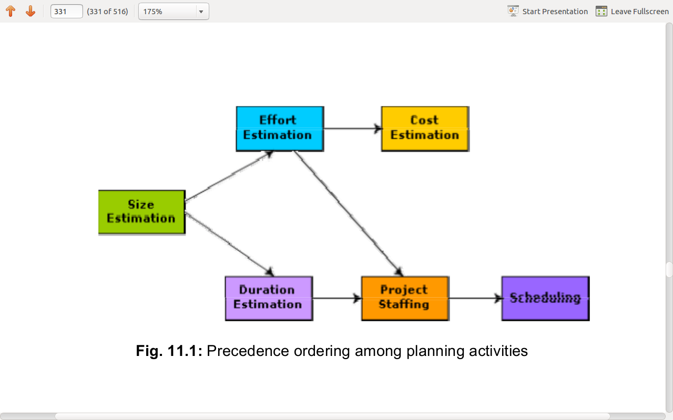
Sliding window planning
- Not possible to plan big projects completely as parameters., scope of project, staff keep changing during the span of the project.
- In order to overcome this problem, sometimes project managers undertake project planning in stages. Planning a project over a number of stages protects managers from making big commitments too early. This technique of staggered planning is known as Sliding Window Planning.
- In the sliding window technique, starting with an initial plan, the project is planned more accurately in successive development stages. At the start of a project, project managers have incomplete knowledge about the details of the project. Their information base gradually improves as the project progresses through different phases. After the completion of every phase, the project managers can plan each subsequent
- phase more accurately and with increasing levels of confidence.

